Design of diaper real-time monitoring system based on MQTT and API

Rong-Ching Wu   
*Department of Electrical Engineering   
I-Shou University*Kaohsiung, Taiwan, R.O.C.  
rcwu@isu.edu.tw

Shu-Fen Chen  
*Department of Nursing*  
*Kaohsiung Medical University Gangshan Hospital*Kaohsiung, Taiwan, R.O.C.  
f880193@gmail.com Yu-Cheng Su  
*Department of Information Engineering  
I-Shou University*Kaohsiung, Taiwan, R.O.C.  
ethan258963@gmail.com

Hung-Chi Chen  
*I_ding Medical Equipment CO.,LTD.*Kaohsiung, Taiwan, R.O.C.  
mail@iding.url.tw Tzu- Wen Wang  
*Department of Electrical Engineering  
I-Shou University*Kaohsiung, Taiwan, R.O.C.  
blackwolf97003@gmail.com

San-Yuan Wang*  
*Department of Information Engineering*Kaohsiung, Taiwan, R.O.C.  
sywang@isu.edu.tw

*Abstract*—This paper aims to address the problem of diaper dermatitis (DD) in newborns caused by delayed diaper changes. A real-time diaper wetness monitoring system based on IoT technology is designed. The perception layer utilizes an RF433 wireless transmission module and a moisture sensor to achieve low-power, real-time, and low-interference detection. When a diaper wetness threshold is reached, the system immediately notifies the caregiver via an alarm and simultaneously transmits the data to a backend server via the MQTT protocol by a microprocessor at the transport layer. The data processing layer utilizes an API and database for storage and statistical analysis. The application layer developed Web and APP interfaces to simultaneously monitor the status of multiple patients across multiple platforms and includes real-time push notifications for alerts. Clinical trials have demonstrated that this system effectively reduces the incidence of DD, hospital stays, and caregiver stress, thereby improving overall care quality. This research has also shown that while MQTT offers real-time performance but exhibits significant latency, APIs offer greater stability and minimal latency, making them suitable for real-time display and management. Overall, this system demonstrates high scalability and practicality, and is poised for future expansion into long-term care and elderly care settings.

Keywords—diaper dermatitis, RF433, microprocessor, MQTT

# Introduction

Because newborns are not yet physiologically mature and do not yet have the ability to control urination and defecation, the use of diapers is a necessary care measure. When newborns are in a medical environment, according to general ward care standards, regardless of whether the patient has wet their diaper or not, they will be checked and changed about every two hours, which is about 12 to 15 times a day [1].

Such an operating procedure can easily delay the best time to change the diaper. If the frequency of diaper wetting is high, the baby will have to endure the discomfort of diaper wetting before the medical staff's inspection period. In addition to urine, the feces of newborns are breast milk feces, which are mainly loose and sticky. The bacteria in the feces decompose to form urea. The skin of the baby's buttocks is delicate and sensitive [2]. When the buttocks are soaked in feces and urine for a long time, the skin is easily damaged and causes redness, swelling, pain and other discomforts, forming DD [3]. The affected area includes the perineum, buttocks, lower abdomen and both sides of the groin [4]. Fig. 1 shows different degrees of DDs [5]. When newborns have DD, they are relatively prone to crying and light sleep due to physical discomfort. Parents also have difficulty getting a light sleep, which reduces the quality of life and work [6].

According to statistics, the incidence of DD in newborns in the neonatal ward of Taiwan Medical Center is 19.9% to 53.6%. Clinically, newborns who have suffered from DD have a higher recurrence rate than those who have not suffered from DD [7]. Therefore, the "incidence of DD " has become an important indicator of medical quality. Factors that cause DD include the characteristics of neonatal skin, irritation from urine and feces, diaper materials, chemical wet wipes, etc. [8]. The most ideal care methods to prevent DD include air, barriers, cleaning, diaper and parent education [9].

With the rapid development of Internet of Things (IoT) technology, sensors and instant messaging modules have matured [10]. The wetness of diapers can be monitored in real time, and a message can be automatically pushed to the caregiver. Newborns no longer need to wait until the next checkup time to change their diapers. This effectively improves care efficiency and prevents newborns from getting DD.

Uddin et al. developed a smart diaper system using IoT technology. Through a built-in moisture sensor and wireless microcontroller, the system can detect diaper humidity in real time and upload the data to the cloud. The mobile application then pushes notifications to users, improving care efficiency and immediate response capabilities [11]. Khan developed a smart wearable device that can be attached to the surface of a diaper. It uses temperature changes to detect infant urination and analyzes events through a hybrid classification algorithm. It pushes notifications to the caregiver’s mobile phone immediately to improve care efficiency. The device is compact, low-energy, low-cost, and does not affect the diaper

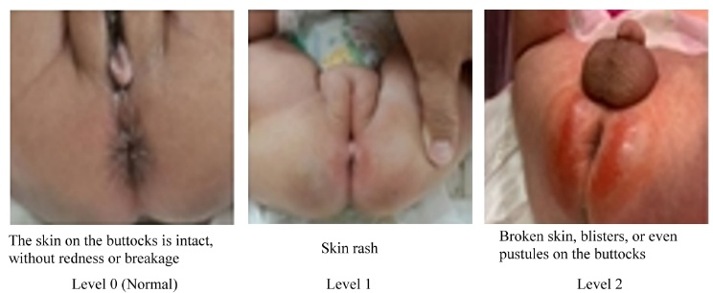

1. Different degrees of DD .

production process [12]. Rahman et al. designed a low-cost smart urine wetness detection system that combines a smartphone with a low-power Bluetooth transmitter. The system senses the wetness of the diaper through a flexible conductor and triggers an alarm when the resistance drops below a preset value, thereby improving the care efficiency and skin health management of patients with severe intellectual disabilities or dementia [13]

While these devices all have basic humidity detection capabilities, most fail to address issues such as battery consumption, limited transmission distance, and limited scalability, making them difficult to fully implement in large-scale care facilities or multi-user environments. Table I compares different approaches.

To address the aforementioned issues, this research proposes a diaper wetness status alarm system with the following features:

*1)* This system utilizes the lightest and most energy-efficient method at the diaper level, minimizing the intrusion of the detector on the newborn.

*2)* When the sensor detects a wetness condition, it instantly notifies the nursing station, even without a network connection.

*3)* When the alarm at the nursing station sounds, it is simultaneously pushed to mobile phones and computers. Caregivers can receive alerts via the internet and terminal devices, allowing them to provide immediate assistance to the care recipient, providing peace of mind for family members.

*4)* This system can simultaneously monitor the diaper wetness status of multiple care recipients. User information, diaper alarms, times, and numbers are recorded in a database for further tracking and statistical analysis.

To achieve these goals, this paper establishes a "Smart Diaper Real-Time Warning System" based on the Open Systems Interconnection model, as shown in Fig. 2. The detailed design is as follows:

*1) Perception layer:* The contact part between the diaper and the patient is built with an RF433 wireless transmission

1. Comparison of different methods

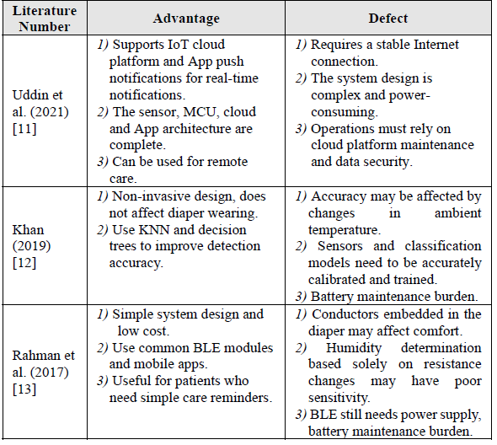

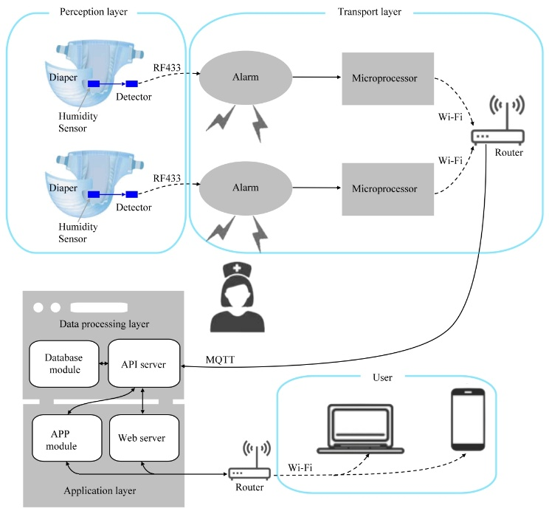

1. System architecture .

module. This allows the diaper end to use the lightest and most energy-efficient equipment and minimizes interference to the newborn.

*2) Transmission layer:* The transmission layer is built with an RF433 wireless receiving module in conjunction with a microprocessor. The RF433 wireless receiving module acts as an alarm, which allows the nursing station to be notified immediately when the diaper humidity reaches the threshold value. The data is sent to the server via the microprocessor MQTT protocol, which can simultaneously process the diaper humidity status of multiple caregivers [14].

*3) Data processing layer:* The database collects user basic information, diaper alarms, time and number.

*4) Application layer:* Design an expandable system architecture to support the simultaneous management and monitoring of multiple users and multiple care objects.

This research system is more practical and has more potential for implementation than existing research in terms of immediacy, scalability and cross-platform application, and has made a positive contribution to the field of smart care.

# System Architecture

This system architecture adopts a conceptual layered design based on the Open Systems Interconnection (OSI) model. The system is divided into four layers: perception layer, transport layer, data processing layer, and application layer.

*1) Perception Layer:* The diaper is used as the sensing medium, equipped with a moisture sensor and detector. The moisture sensor is installed in an appropriate position on the diaper to detect moisture. The detector is electrically connected to the moisture sensor. When the moisture value exceeds a set threshold, it sends a signal to the alarm module.

*2) Transport layer:* It includes an alarm and a microprocessor. The transport layer hardware is installed at the nursing station. When the alarm receives the RF433 signal, it will immediately sound to alert the caregiver and input the signal into the microprocessor. The microprocessor is connected to the router via Wi-Fi and uploads the data to the backend API server through the MQTT transmission protocol [15].

*3) Data Processing Layer:* The data processing layer includes an API server and a database module. The API server receives alarm numbers and statuses uploaded by the microprocessor and transmits them to the database module. The database module stores historical data for subsequent query and statistical analysis.

*4) Application Layer:* The application layer includes a Web server and mobile APP module. Connected to the data processing layer, it receives humidity alerts in real time and displays them instantly via a webpage or mobile device. This system can simultaneous display of device status across multiple platforms.

*A. Perception Layer*

The perception layer includes a humidity sensor and detector, as shown in Fig. 3. This system's humidity sensor uses a two-wire resistance measurement module. This module is constructed from existing wires and absorbent materials. It offers the advantages of low cost, disposable design, and simple structure. Resistance measurement determines the degree of moisture in the system based on the resistance between the wires. Higher humidity results in lower resistance.

A 3 Kg newborn baby has a daily urine output of approximately 90–180 ml and 5–8 bowel movements. The conductivity of newborn urine is approximately 2–10 mS/cm. This is primarily related to the electrolyte concentration. Higher conductivity indicates a higher concentration of dissolved ions in the urine. Conductivity is also affected by factors such as water intake, dehydration, fever, diarrhea, and diet. The detector in this system is set to a threshold of approximately 40 ml of urine or stool. When the resistance measurement module's detection value exceeds the set threshold, the detector transmits a signal to the alarm via the RF433 module.

The detector circuit uses an RF433 transmitter. RF433 is a wireless radio frequency communication technology that operates in the 433MHz frequency band. It is a common, low-power, short-range wireless communication method widely used in home automation devices. The communication range

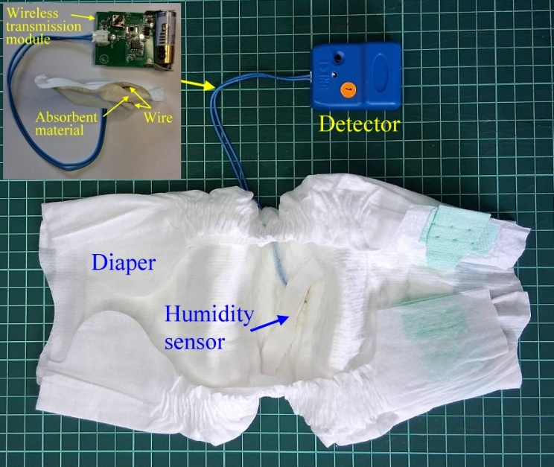

1. Appearance and circuit of the perception layer.

is approximately 10 meters. It has the advantages of low power consumption, suitability for battery-powered devices, and low cost.

*B. Transport Layer*

The transport layer consists of an alarm, a microprocessor, and a router, as shown in Fig. 4. The alarm is an RF433 wireless receiver module. When a signal from the detector is received, an alarm sounds to alert the caregiver. The microprocessor and alarm are electrically connected. When the alarm is triggered, its output signal is simultaneously input to the microprocessor's GPIO pins for simultaneous broadcasting to mobile phones and computers. This system uses an ESP32 as the microprocessor. The ESP32 has the following key features: built-in Wi-Fi and Bluetooth, supporting low-power modes, suiting for long-term operation, the transmission path covers both the website server and the API server. It makes the ESP32 suitable for IoT applications. The microprocessor sends messages to the server using the MQTT protocol.

In IoT applications, sensor data needs to be transmitted to backend servers or mobile devices via communication protocols. Common communication protocols include HTTP and MQTT. To achieve lightweight and real-time performance, this study uses the MQTT communication protocol. MQTT has the following advantages: support for subscription/publishing mode, suitable for multi-device transmission, small packet size, high security. This protocol is suitable for wireless transmission environments and is compatible with common cloud platforms such as Mosquitto and HiveMQ [16]. This system uses Broker to help manage data publishing and subscription for multiple devices, so as to meet the needs of the smart care environment.

*C. Data Processing Layer*

The data processing layer consists of an API server and a database module, responsible for data reception, analysis, configuration, and storage. Fig. 5 shows the API server screen, and Fig. 6 shows the database module screen. The API server's primary function is to receive alarm numbers and alarm status data from the microprocessor and display the relevant information in real time on an HTML webpage. Furthermore, the API server stores processed data in JSON format in the database module for subsequent querying, statistical analysis, and historical comparison. The database module is connected to the local API server. The database module is responsible for storing historical records and system parameter settings, supporting back-end data queries and real-time data display in the user interface. Overall, the data processing layer plays a core role in the system, providing data conversion, logical analysis, and decision making.

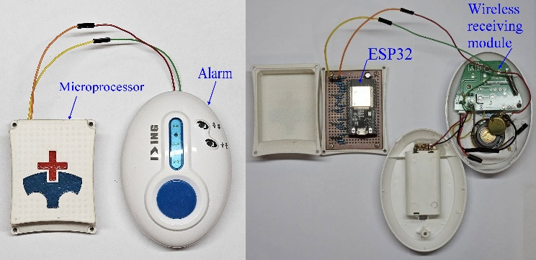

1. Transport layer appearance and circuit.

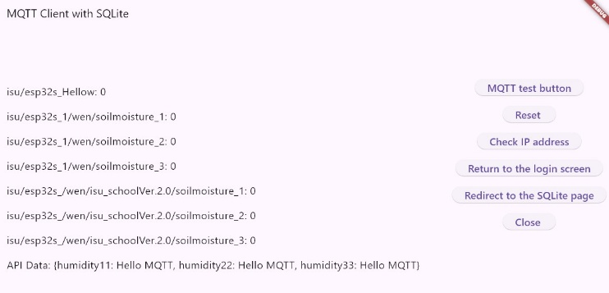

1. API server screen.

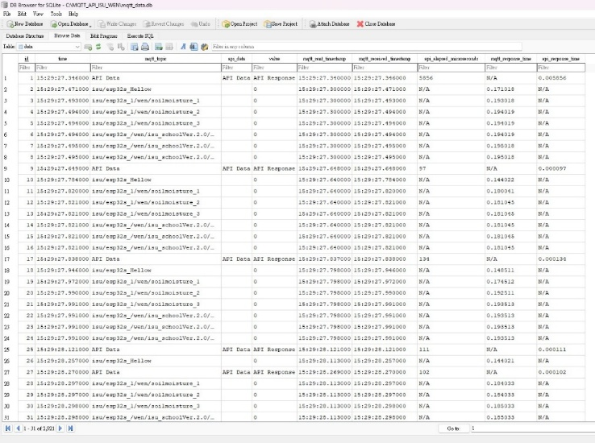

1. Database module screen.

*D. Application Layer*

The application layer includes a Web server and an APP module. The server module transmits a warning message to the terminal device via the network. The system's application layer uses Flutter to develop the website and APP, providing a simple and intuitive interface. Fig. 7 shows the APP module screen, and Fig. 8 shows the Web server screen. This system supports multi-user detection, allowing multiple detection modules and wireless modules to be installed on the diapers of multiple caregivers for simultaneous monitoring. The server records the status of each device separately, allowing multiple caregivers to query or manage the system simultaneously. Users can instantly view the alarm status of all online diapers. When a diaper reaches a wetness threshold, the system instantly updates the event status on the front-end screen of their mobile phone or computer. It displays alarm time and diaper number. Different conditions are indicated by red or green colors. Caregivers can monitor the diaper's alarm status in real time via the webpage or mobile APP.

*E. Software Process and Decision Logic*

Perception Layer Design Process:

*1)* The humidity sensor is placed inside the diaper to detect humidity changes. The detector is placed next to the diaper.

*2)* If the humidity exceeds the threshold, the detector wirelessly transmits an alert signal to the alarm.

Transmission Layer Design Logic:

*1)* The microprocessor reads the detector's alarm data at regular intervals and classifies it as either normal or requiring

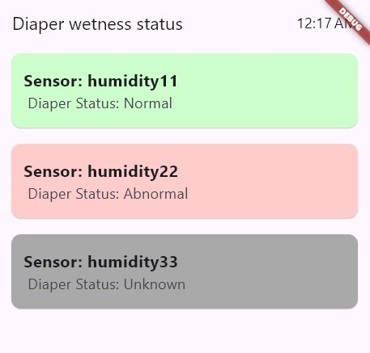

1. 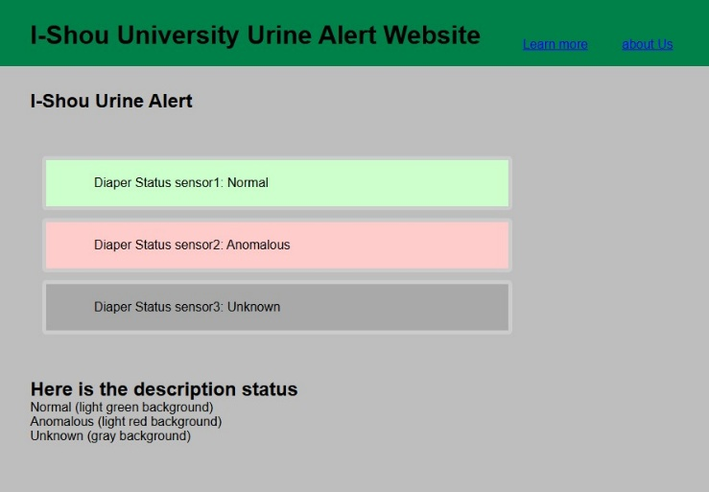APP module screen.
2. Web server screen.

replacement based on the alarm status. If the status differs from the previous one, it is considered a status change.

*2)* The microprocessor sends an MQTT message to a designated topic, containing a timestamp, diaper number, and alarm status.

The data processing layer design process: Receives the specified MQTT topic, subscribes to the specified topic, receives and parses the message format, organizes the MQTT data, stores it, and sends it to the API.

The application layer design process:

*1)* Requests the backend API to obtain real-time alarm status data.

*2)* Displays color information based on the severity of the alarm.

# Results and Discussion

## Delay Analysis

To test the API server delay under long-term MQTT device operation, this study used five MQTT devices to simultaneously transmit humidity data to the API server. One transaction was sent per second for 1000 seconds. The difference between the API server's timestamp and the MQTT device's timestamp represents the delay. Fig. 9 shows the delay trends for this test. Overall, the delay for most devices remained stable below 0.7 seconds. This is ideal for instant diaper alert applications. However, at certain times, certain devices (such as #1) exhibited significantly lower delay. This "delay discrepancy" and the resulting graph pattern are hypothesized to be related to the following factors: incomplete synchronization of the sending and receiving timestamps; momentary network congestion caused by simultaneous device transmissions; Wi-Fi bandwidth sharing and collision retransmissions; and MQTT server processing bottlenecks. These synchronization fluctuations indicate potential delay impacts, especially when multiple devices are transmitting simultaneously.

## Delay Comparison

Fig. 10 further compares the delay of an MQTT device and HTTP over multiple transmissions. For HTTP delay analysis, the Stopwatch() function was used to record the start and response time of each HTTP request to calculate HTTP processing delay. All data was stored in SQLite database for subsequent statistical analysis. The results show that MQTT's average delay is significantly faster than HTTP's, with an average delay of approximately 0.27 seconds for MQTT and approximately 1.23 seconds for HTTP. The delay fluctuation range for MQTT is also very narrow. This difference reflects the nature of the two transmissions. Although MQTT transmission involves multiple links, including devices, wireless networks, MQTT brokers, and API servers, its lightweight communication protocol, small data packets, and relatively low system computation and bandwidth requirements ensure low delay across various devices and network environments, effectively reducing system resource consumption. In contrast, HTTP transmission is primarily used for data storage and processing within servers, typically employing a request/response model. Each transmission requires establishing a full connection and carries a significant amount of header information, resulting in relatively high

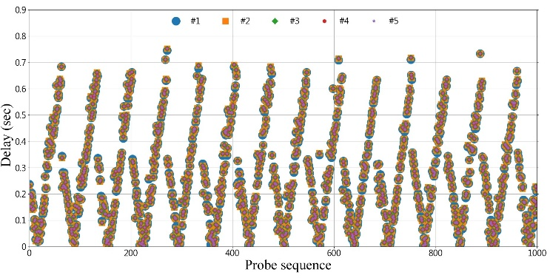

1. 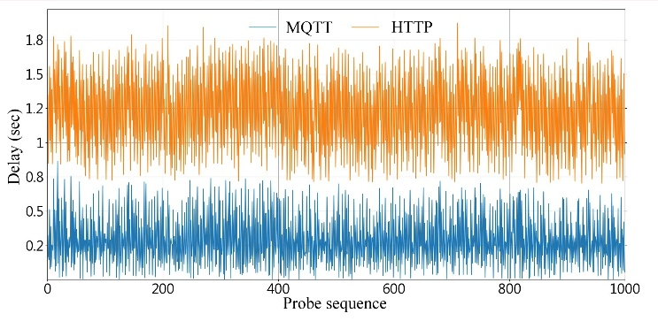Trend of MQTT device delay.
2. Delay time comparison between MQTT and HTTP.

system resource requirements and delay. Comparison results show that in multi-device data upload scenarios, the primary delay differences arise from the transmission protocol itself and the network environment, rather than the server's internal data processing speed.

## Delay Distribution

Fig. 11 shows the delay distribution for MQTT and HTTP transmissions. MQTT's delay distribution ranged from 0.29 ± 0.20 seconds, with only a few instances exhibiting unusually long delays exceeding 0.7 seconds. This indicates that occasional delays can occur under certain conditions. In contrast, HTTP's delay was primarily concentrated within a range of 1.23 ± 0.29 seconds, with a more dispersed distribution. This indicates a longer average delay and less stable delay. Overall, MQTT demonstrated lower delay and greater consistency under these test conditions, while HTTP exhibited greater instability in both latency and latency variation.

## Clinical Validation

This system was used in clinical care at a medical center in Kaohsiung. This study was approved by the Institutional Review Board of Kaohsiung Medical University Hospital (KMUIRB-SV(I)-20210050). This article compares the results of this system before and after the improvement of DD problem, as shown in Table II. Before DD improvement, it was the standard operation of general ward care. After DD is improved, this system will intervene in clinical care and revise the standard operation of DD care. To compare the differences between the two, this study defined the following metrics:

IOA is total incidence of DD in infants.

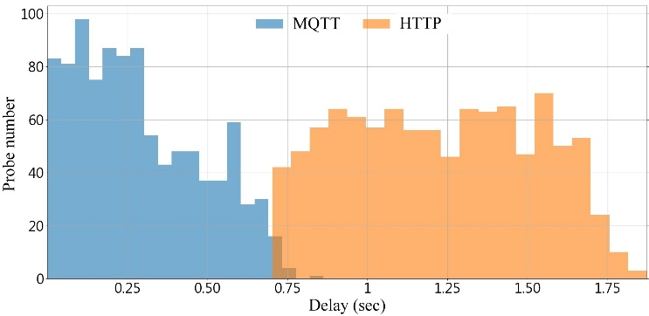

1. Delay time distribution comparison.
2. Comparison between before and after improvement

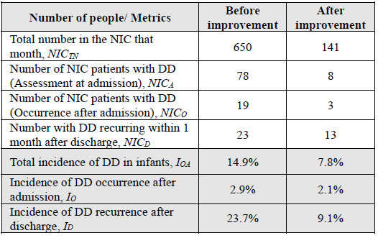



Where:

*NICTN*is total number in the neonatal intensive care unit (NIC) that month.

*NICA*is the number of NIC patients with DD (Assessment at admission)[17].

*NICO*is the number of NIC patients with DD (Occurrence after admission).

*IO* is incidence of DD occurrence after admission.



*ID* is incidence of DD recurrence after discharge.



Where *NICD* is the number with DD recurring within 1 month after discharge.

Table 2 shows that the in-hospital DD incidence rate decreased from 2.9% to 2.1%, an improvement of 27.6%. Furthermore, these improvements have reduced the length of stay for children with DD. The average length of stay has decreased from 9.5 days to 7.6 days, and bed turnover has increased significantly. The post-discharge DD recurrence rate has decreased from 23.7% to 9.1%, an improvement of 61.6%. This system has also improved the quality of care after newborns return home. It reduces the risk of infant discomfort caused by inexperienced caregivers. Implementation has not only reduced the incidence of diaper dermatitis in both in-hospital and out-patient settings, but has also improved the quality of care.

# Conclusion

This study developed a diaper wetness status alert system. The system provides a safe and friendly environment for infants to receive medical treatment, and also improves the quality of care after returning home. This research combined sensing technology, IoT communication protocols, and an instant notification mechanism. In addition to sending alerts to the nursing station, notifications can also be sent via social media APPs such as LINE, demonstrating good system scalability and practicality. This system achieves the goal of improving nursing efficiency and patient care quality.

The system's data transmission capabilities were explored. MQTT's latency was long and highly volatile, while API's latency was stable and low. This suggests that MQTT is more suitable for data transmission between devices, while API is more suitable for real-time monitoring and alarm systems. These results demonstrate the reliability and immediacy of the monitoring system in a multi-device environment. Using this system in the care of newborns with DD has significantly reduced both the in-hospital incidence and the recurrence rate of DD after discharge. This has prevented newborns from having extended hospital stays due to DD. The average length of stay has also been significantly reduced, leading to a relative improvement in bed turnover.

The diaper warning system designed by this institute can effectively improve the timeliness and accuracy issues in traditional care processes. In the future, the system can be continuously optimized and promoted to elderly care and long-term care settings.

##### Acknowledgment

The implementation of this paper is incredibly grateful for the support of the Ministry of Science and Technology, project number NSTC 112-2221-E-214 -002 -MY2.

##### References

1. K. Hugill, "Revisiting infant nappy dermatitis: Causes and preventive care," British Journal of Midwifery, vol. 25, no. 3, pp. 150–154, 2017.
2. J. Nikolovski, G. N. Stamatas, N. Kollias, and B. C. Wiegand, "Barrier function and water-holding and transport properties of infant stratum corneum are different from adult and continue to develop through the first year of life," J. Invest. Dermatol., vol. 128, no. 7, pp. 1728–1736, 2008.
3. S. M. Nourbakhsh, H. Rouhi-Boroujeni, M. Kheiri, et al., "Effect of topical application of the cream containing magnesium 2% on treatment of diaper dermatitis and diaper rash in children: A clinical trial study," J. Clin. Diagn. Res., vol. 10, no. 1, pp. WC04–WC06, 2016.
4. U. Blume-Peytavi, M. Hauser, L. Lünnemann, et al., "Prevention of diaper dermatitis in infants: A literature review," Pediatr. Dermatol., vol. 31, no. 4, pp. 413–429, 2014.
5. M. S. Esser and T. S. Johnson, "An integrative review of clinical characteristics of infants with diaper dermatitis," Adv. Neonatal Care, vol. 20, no. 4, pp. 276–285, 2020.
6. M. Adib-Hajbaghery, M. Mahmoudi, and M. Mashaiekhi, "The effects of bentonite and calendula on the improvement of infantile diaper dermatitis," J. Res. Med. Sci., vol. 19, no. 4, pp. 314–318, 2014.
7. M. Young, The Technical Writer’s Handbook. Mill Valley, CA: University Science, 1989.
8. C. Glashan, "Designing and implementing a skin care protocol for infants with neonatal abstinence syndrome to decrease rates of diaper dermatitis," Adv. Neonatal Care, vol. 22, no. 1, pp. 35–41, Feb. 2022.
9. O. Burdall, L. Willgress, and N. Goad, "Neonatal skin care: Developments in care to maintain neonatal barrier function and prevention of diaper dermatitis," Pediatr. Dermatol., vol. 36, no. 1, pp. 31–35, 2019.
10. H. Alam, M. M. Burhan, I. ul Haq, M. A. Arshed, A. Gillani, M. Shafi, and S. Ahmad, "IoT based smart baby monitoring system with emotion recognition using machine learning," Wireless Commun. Mobile Comput., Article ID 1175450, Apr. 2023.
11. M. S. Uddin, S. Islam, and N. Vasker, "Smart diaper: Non-stop diaper monitoring system," in Proc. 2021 IEEE Int. Conf. Robot., Autom., Artif. Intell. Internet Things (RAAICON), 2021, pp. 1–5.
12. S. Khan, "A noninvasive smart wearable for diaper moisture quantification and notification," Int. J. Electr. Comput. Eng. (IJECE), vol. 9, no. 4, pp. 3071–3078, Aug. 2019.
13. M. S. Rahman, C. Choi, Y.-P. Kim, and S. Kim, "A low-cost wet diaper detector based on smartphone and BLE sensor," Int. J. Appl. Eng. Res., vol. 12, no. 19, pp. 9074–9077, Jan. 2017.
14. W. A. J. Al Areeqi, H. K. Shang, S. N. I. S. Hamid, et al., "IoT BBMS: Internet of Things based baby monitoring system for smart cradle," IEEE Access, vol. 7, pp. 93791–93805, May 2019.
15. Z. T. Shao, M. X. Huang, D. Wu, X. Zhang, and A. Huang, "Design of a simplified wireless sensor network node based on MQTT protocol," ResearchGate Preprint, Jun. 2019.
16. M. A. B. Sohail, M. Rehan, and M. H. Kabir, "IoT based smart health monitoring system using MQTT protocol," ResearchGate Preprint, Jun. 2019.
17. B. S. Buckley, J. B. Mantaring, R. B. Dofitas, M. C. Lapitan, and A. Monteagudo, "A new scale for assessing the severity of uncomplicated diaper dermatitis in infants: Development and validation," Pediatr. Dermatol., vol. 33, no. 6, pp. 632–639, 2016.